Free & Easy Tech to Help Your Instruction

LOEX 2014

Free & Easy Tech to Help Your Instruction

Tools4InfoLit.wordpress.org

Poster session:

Alexa Clark & Angelia Pulley

University of Kentucky

Angelia Pulley

SLIS Graduate Student

University of Kentucky

[angelia.pulley@uky.edu](mailto:angelia.pulley@uky.edu)

Alexa Clark

User Experience Librarian

Spalding University

[aclark08@spalding.edu](mailto:aclark08@spalding.edu)

(502) 873-4380

PowToon

What you get:

* **Professional-Looking Videos**
* **Export to YouTube With One Click**
* **Create Videos Up to 5 Minutes Long**
* **10 Royalty Free Tunes**
* **10 Royalty Free Styles**
* **Unlimited Chances to Add Your Own Art**
* **Unlimited Storage**
* **Completely free**

How can librarians use it?

* **Introduce services provided by library**
* **Explain important concepts**
* **Promote information literacy to faculty**
* **Add a touch of humor to a drab instruction**

Example



Macintosh HD:Users:aclark:Desktop:LOEX:powtoon logo .png

www.powtoon.com

Easel.ly

What you get:

* **Pre Designed Visual Themes aka VHEMES**
* **Thousands of free infographic templates and design objects**
* **Design your own template from scratch**
* **Easy drag and drop elements**
* **Easy to edit and share your work**
* **Completely free: no fees or subscriptions**

How can librarians use it?

* **Customize visual concepts**
* **Convey thoughts**
* **Design lesson plans**

Example

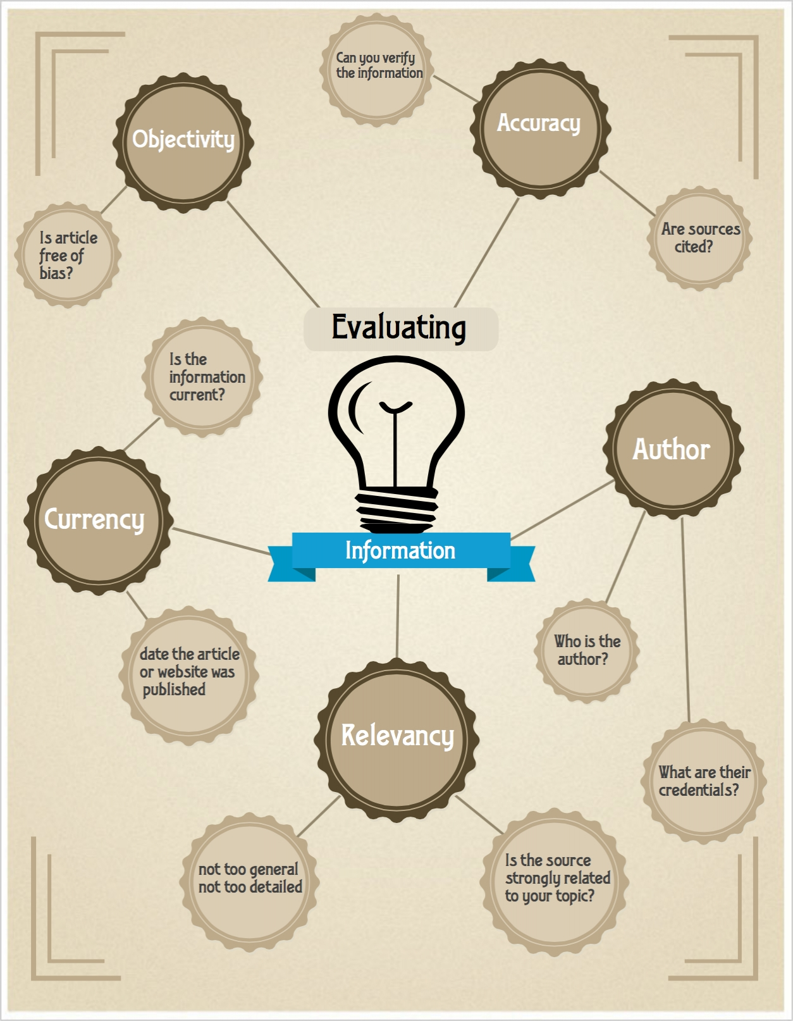



http://www.easel.ly/

Jing

What you get:

* **Grab Any Image You See On Your Screen**
* **Record Everything That Occurs in One Window**
* **Save Them to Your Computer**
* **Step-by-Step Tutorials Offered to Help You**
* **TechSmith Offers Free Tech Support**
* **Available on Mac OS and Windows**
* **Completely free**

How can librarians use it?

* **Record search strategies & solutions**
* **Effectively coach, encourage, and inspire students and colleagues**
* **Point of need instruction for distance learners**

Example

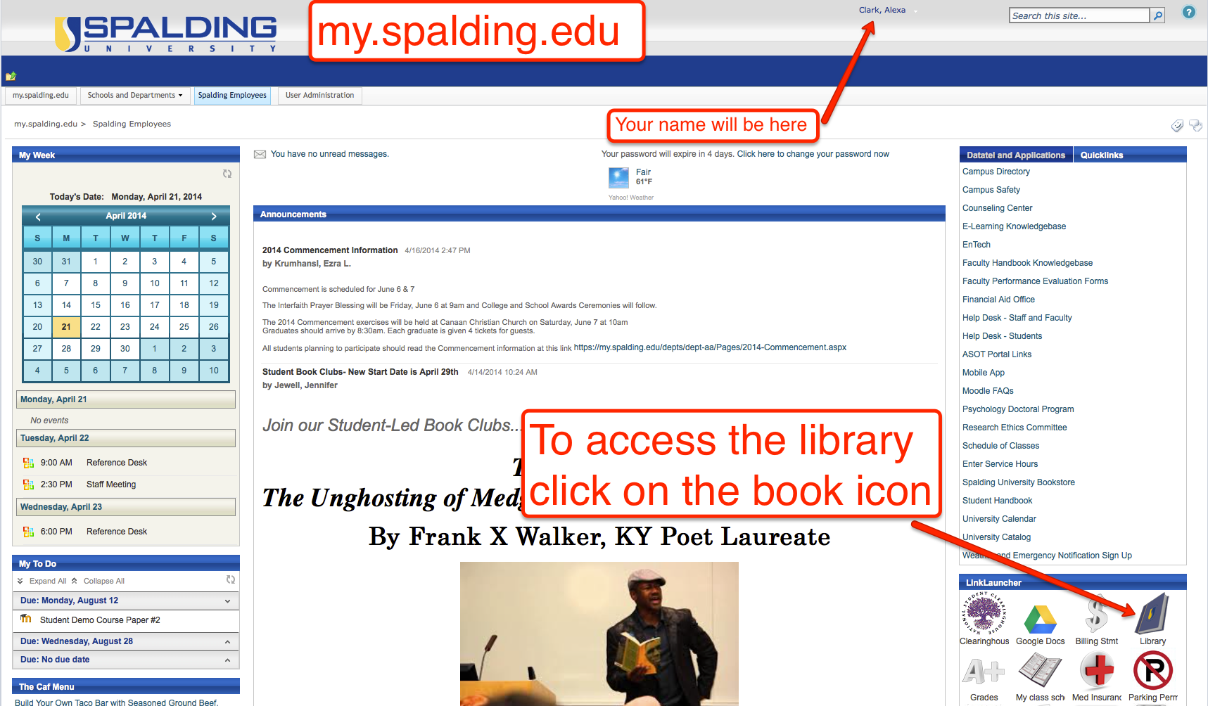

**Macintosh HD:Users:aclark:Desktop:LOEX:jing-logo-gray.png**

http://www.techsmith.com/jing.html